
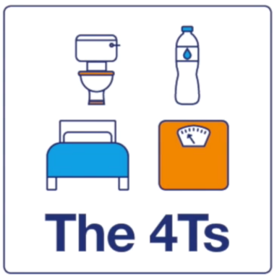
Know the ‘4 T’s’ of Type 1 diabetes - it could save a child’s life
It’s really important to be able to spot the most common symptoms of type 1 diabetes early.
Unfortunately, we know that too many people – mostly children and young people – are not diagnosed until they are in diabetic ketoacidosis (DKA), a life-threatening condition that requires urgent medical attention.
Early action is important and it’s good to know the ‘4 T’s’ of type 1 diabetes:
Toilet – going to the toilet a lot.
Thirsty – being very thirsty and unable to quench the thirst.
Tired – feeling more tired than usual.
Thinner – losing weight or looking thinner than usual.
If you notice these signs and symptoms, you should contact your doctor straight away.

If you would like support…
Join our ‘Friends of the North’ Diabetes UK Facebook group where you can find peer support and the latest information from Diabetes UK, locally and nationally: Diabetes UK chat: Your Friends in the North | Facebook
Or use your mobile phone to scan the QR code:
Contact us:
North of England team: 01925 653281
Diabetes UK Helpline: 0345 123 2399 (Mon-Fri, 9am-6pm)

For more information…
If you would like copies of the poster or the A5 leaflets, please contact north@diabetes.org.uk.
For more information about Diabetes UK visit www.diabetes.org.uk/The4Ts
We have resources to help you support pupils who have type 1 diabetes. Find out more about how we can support schools and our resources to help Diabetes in schools resources | Diabetes UK

