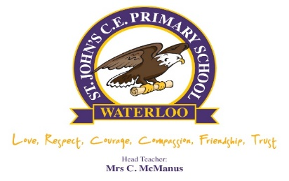

July 7th 2025
Dear Parents/Guardians,

As part of your child’s education at St. Johns Primary School, we promote personal wellbeing and development through our Personal, Social, Health and Citizens Education (PSHCE).
PSHE is the curriculum subject that gives the children the knowledge, understanding, attitudes and practical skills to live safe, healthy, productive lives and meet their full potential.
At St. John’s, we follow the Jigsaw PSHE sex and relationship education unit of work which aims to give children their entitlement to information about relationships, puberty and human reproduction, appropriate to their ages and stages of development.
It is treated in a matter-of-fact manner to allay embarrassment and fear. We do not believe it is controversial. It is flexible enough for a school to ensure that the material fits its ethos and values. There is a strong safeguarding element to Changing Me – the unit of work that teaches sex and relationship education.
The Department for Education has made Relationships Sex Education and Health Education compulsory in all schools. Relationship Education is statutory for all primary schools and part of the curriculum.
The new guidance focuses on healthy relationships and keeping children safe in the modern world. It also covers a range of topics relating to physical wellbeing, mental wellbeing and safeguarding. Our current Sex and Relationship Education policy and unit of work can be viewed on the school website: Parents> Policies.
There are four main aims for teaching SRE within the context of Primary School PSHE (Personal,
Social, Health and Economic) Education:
• To enable young people to understand and respect their bodies, and be able to cope with the changes puberty brings, without fear or confusion
• To help young people develop positive and healthy relationships appropriate to their age, development, etc. (respect for self and others)
• To support young people to have positive self-esteem and body image, and to understand the influences and pressures around them
• To empower them to be safe and safeguarded
We are therefore informing our parents and guardians of the delivery of the Relationships topic in term 2 of the summer term. All sessions will be age appropriate and meet the needs of all pupils in the class. Each year group’s focus will be:
Foundation Growing up: how we have changed since we were babies
Year 1: Boys’ and girls’ bodies; body parts
Year 2: Boys’ and girls’ bodies; body parts and respecting privacy (which parts of the body are private and why this is)
Year 3: How babies grow and how boys’ and girls’ bodies change as they grow older
Year 4: Internal and external reproductive body parts, body changes in girls and menstruation
Year 5: Puberty for boys and girls, and conception
Year 6: Puberty for boys and girls and understanding conception to birth of a baby
All lessons are taught using simple, child-friendly language and pictures, which help children
understand changes more effectively.

PSHE is monitored and reviewed regularly by staff and the governing body. All PSHE teaching takes place in a safe learning environment and is underpinned by our school Christian ethos and values. A variety of opportunities will be provided for pupils to ask questions to further their understanding and to find out more about what affects them personally.
Yours sincerely
J.Waring
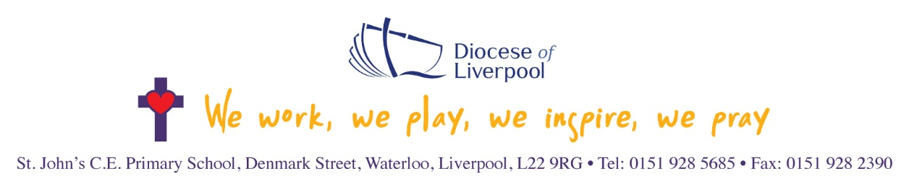
Mrs Waring
Assistant Head Teacher

